# Report: Website Improvement Recommendations for ISEFY

**Compared with （Eufy, reolink, Ring,Arlo,Lorex,TP-Link,Defender Guard)**

## Executive Summary:

This report analyzes the current state of ISEFY's website and provides recommendations for improvement based on insights gained from reviewing Lorex, Eufy, and Arlo websites. The objective is to enhance user experience, improve product visibility, increase conversions, and establish a professional and user-friendly online presence.

## Homepage Improvements

- Include a large, visually appealing product ecosystem graphic that illustrates how ISEFY products integrate and work together.

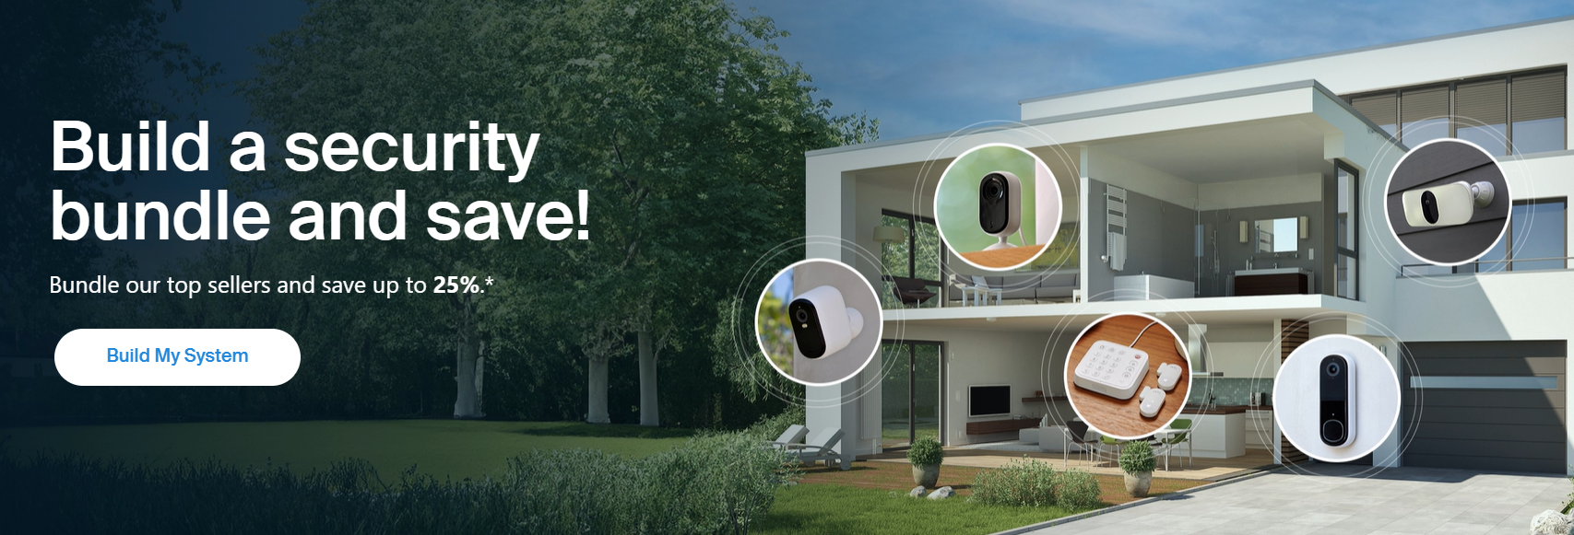

- Add sections for showcasing seasonal or holiday-specific discounts with clear CTAs like 'Shop Now' or 'Learn More.'

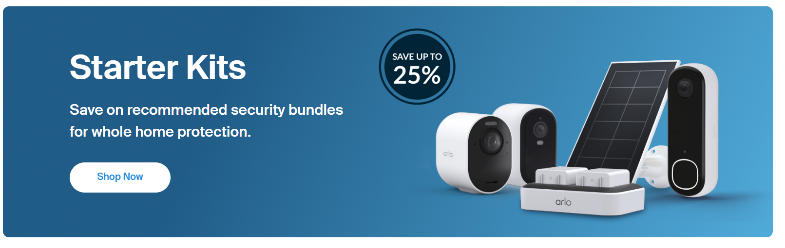

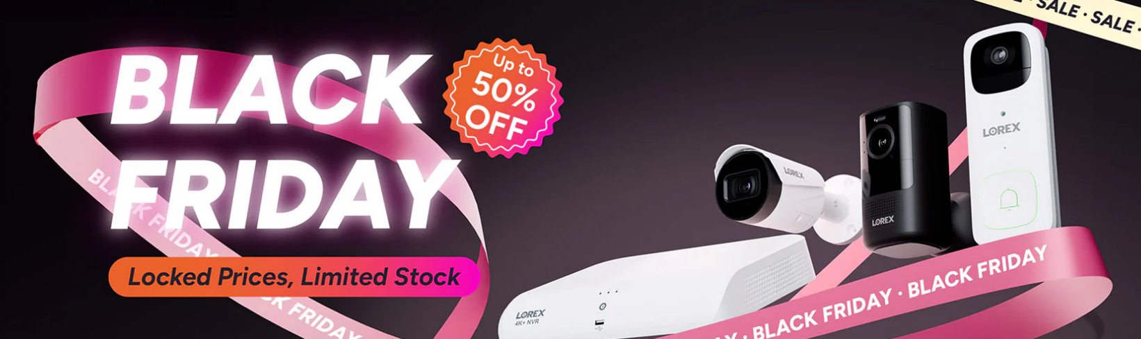

- Display major product categories or flagship products with high-quality images and direct options for 'Learn More' and 'Buy Now.'

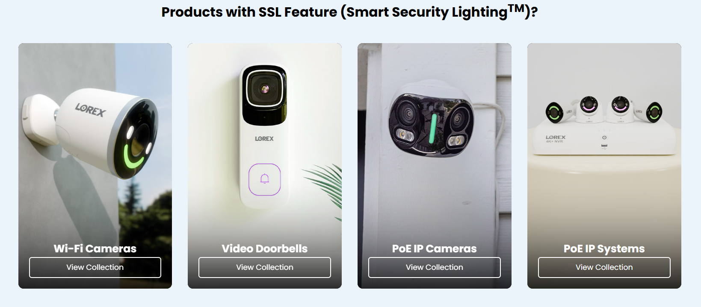

- Create a dedicated section to promote cloud storage services, highlighting benefits like data security, accessibility, and competitive pricing.

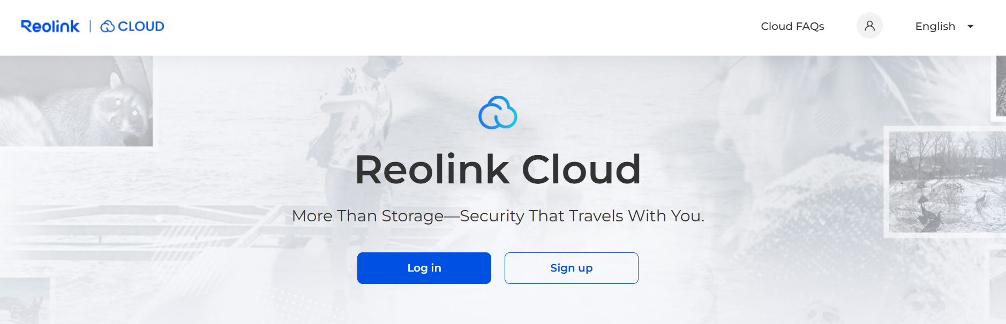

- On the top of the website. Develop a comprehensive search bar that features autosuggestions and dropdown menus when users hover, showing popular searches and categories.

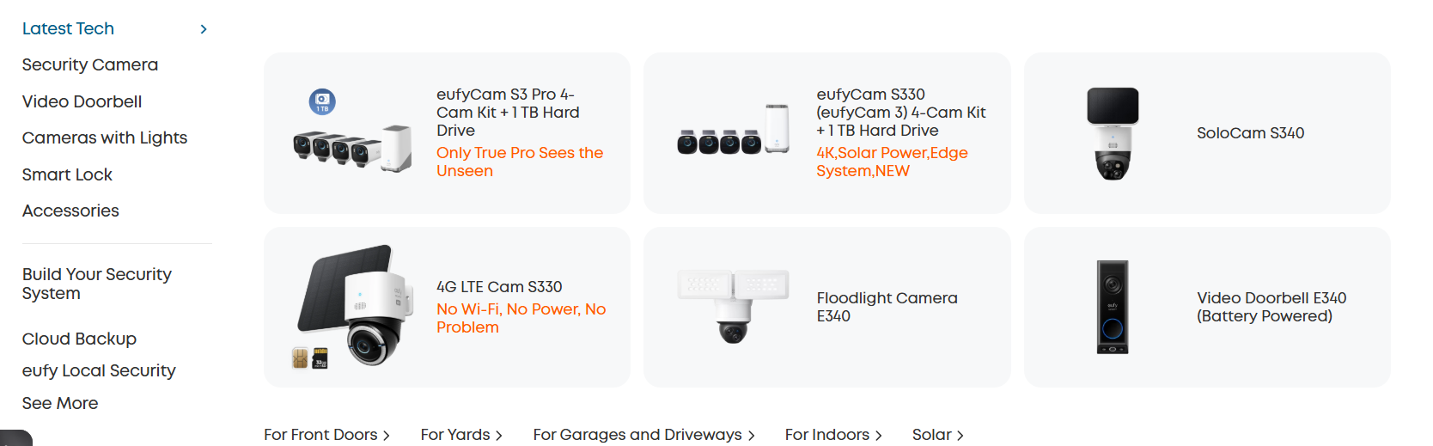

- Improve the footer with links to FAQs, customer support, terms of service, privacy policies, and quick links to product categories.

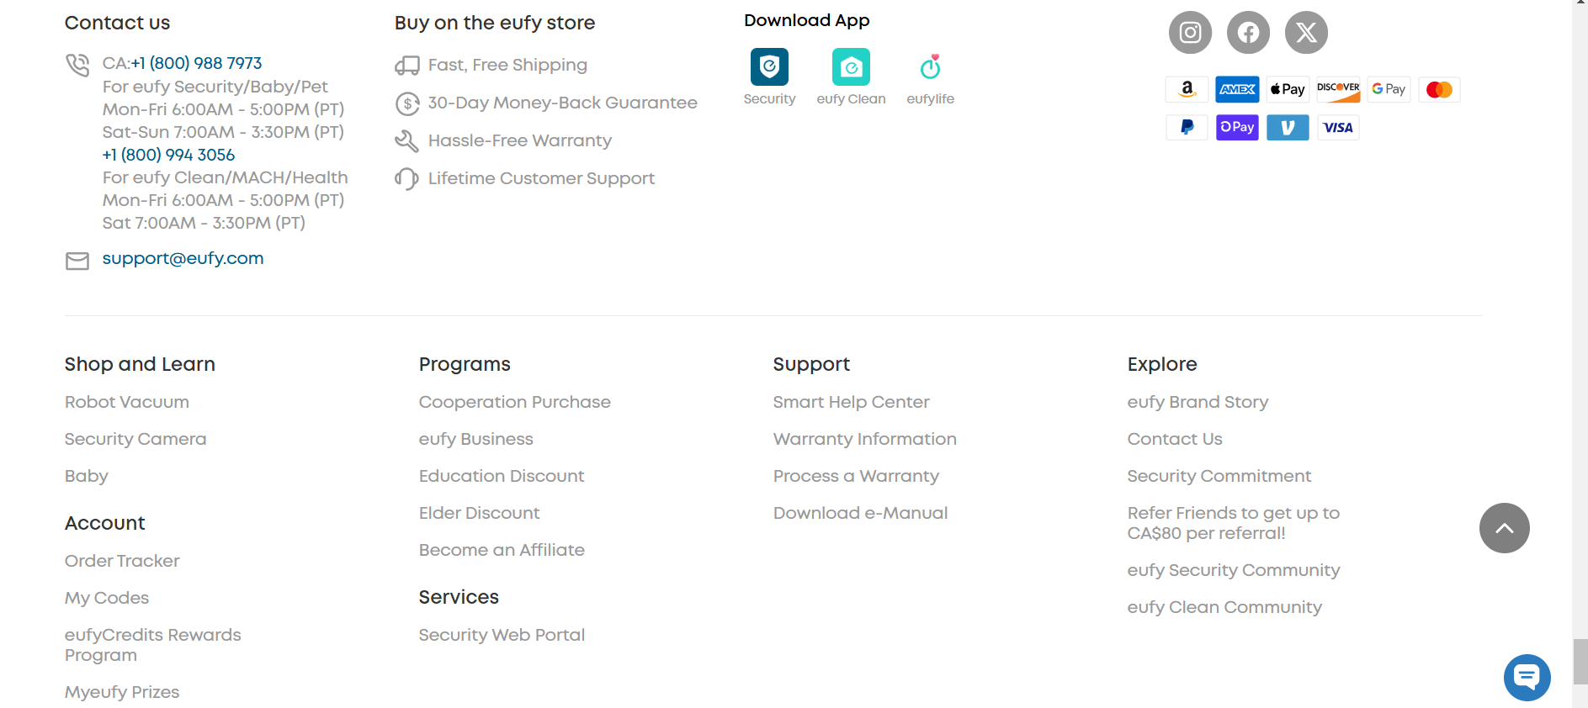

- Add a prominent link to the online store and ensure account management functionalities like order tracking, wishlist creation, and subscription management are accessible.

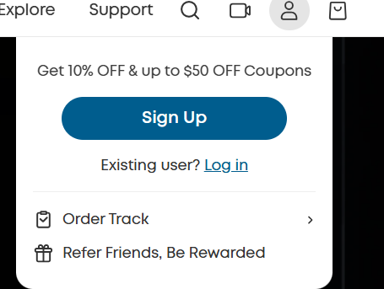

- Provide direct access to customer support options, including live chat, phone support, and a ticketing system.

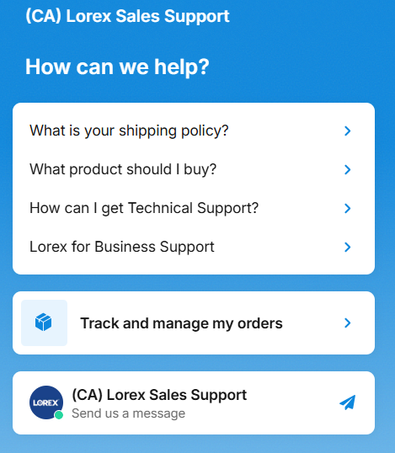

- Introduce a community forum or user space where customers can share reviews, tips, or setup guides.

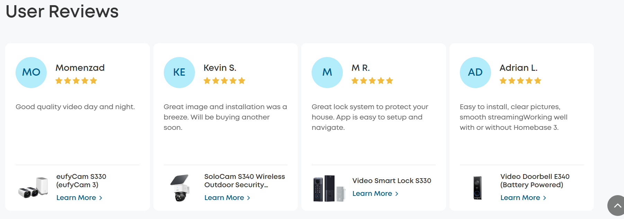

-Introduce famous partner:



## Product Details Pages

- Build comprehensive product descriptions based on the predefined feature lists, covering specifications, benefits, and ideal use cases.

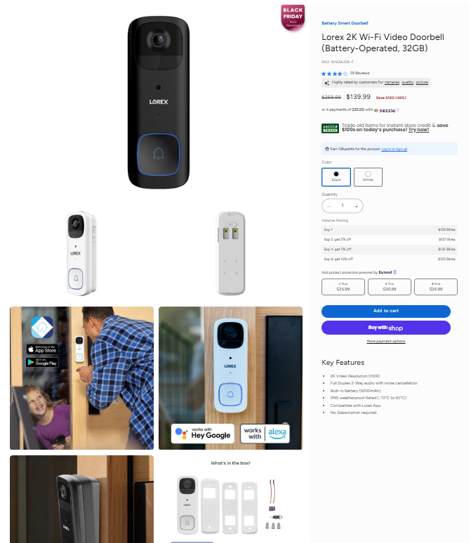

First, the left side should include an ecosystem diagram of the product and images such as "what's in the box." The right side should contain text descriptions of key features and purchase options.

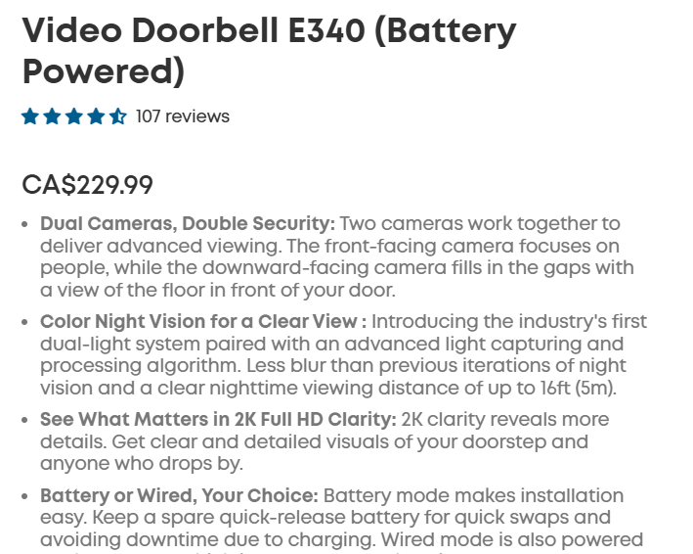

- Integrate videos and multiple high-quality images, including 360-degree views and lifestyle shots. ** include how the features are displayed in the app.

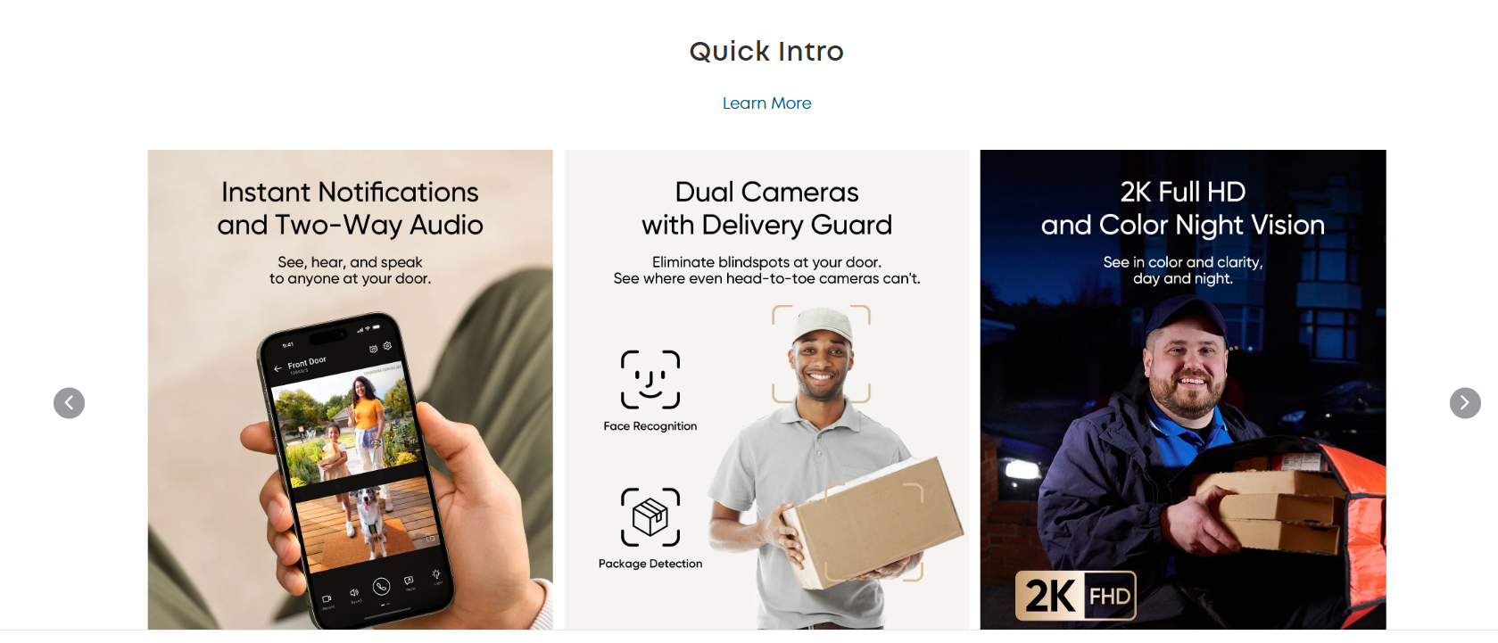

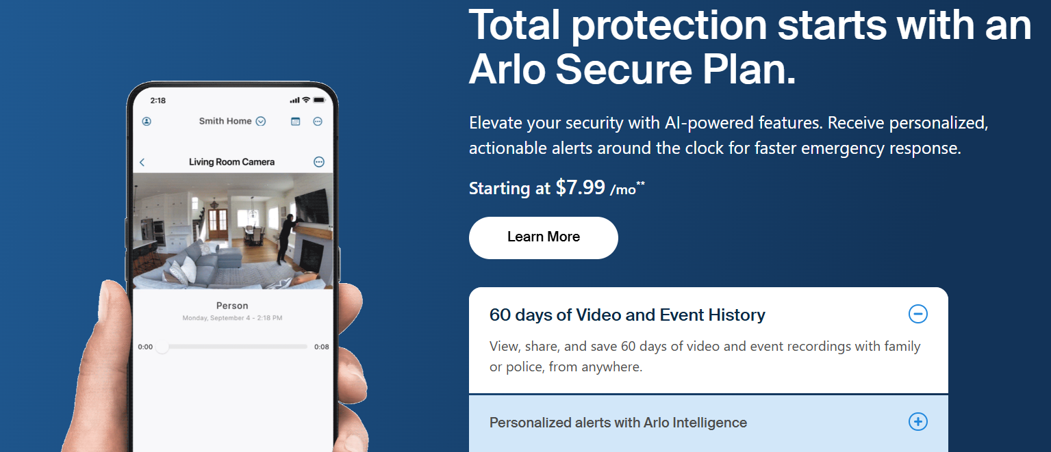

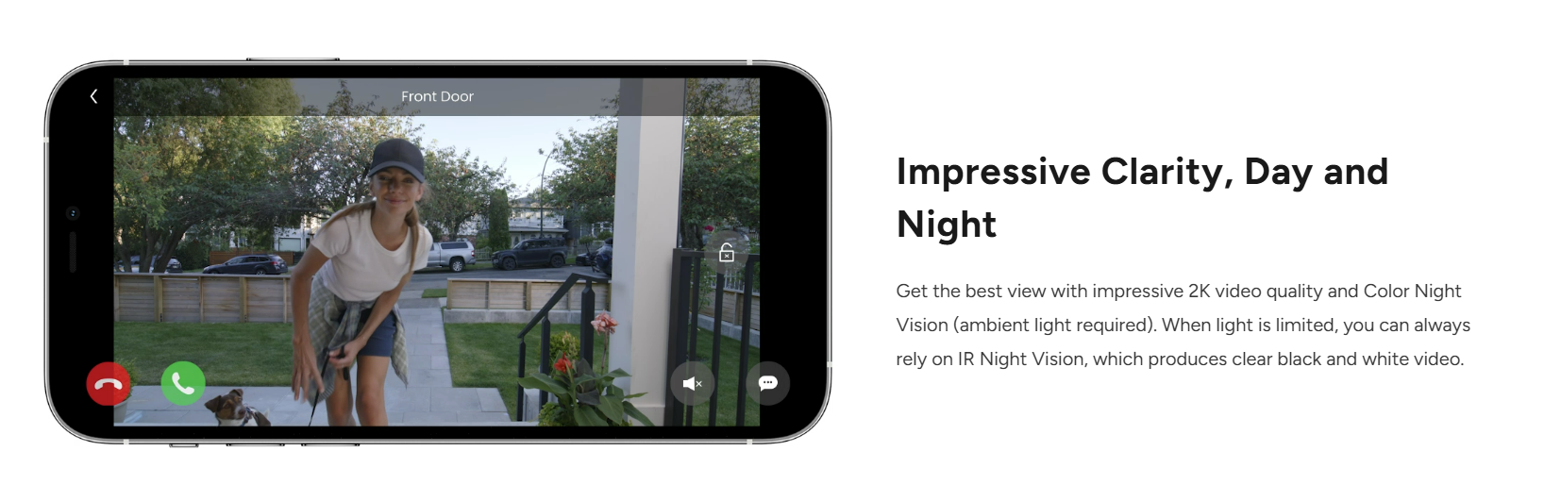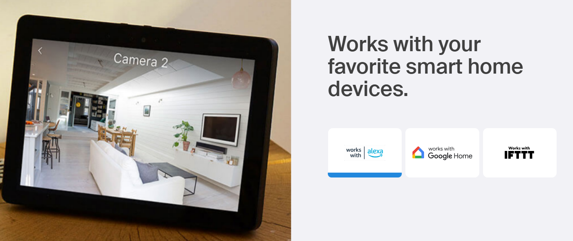

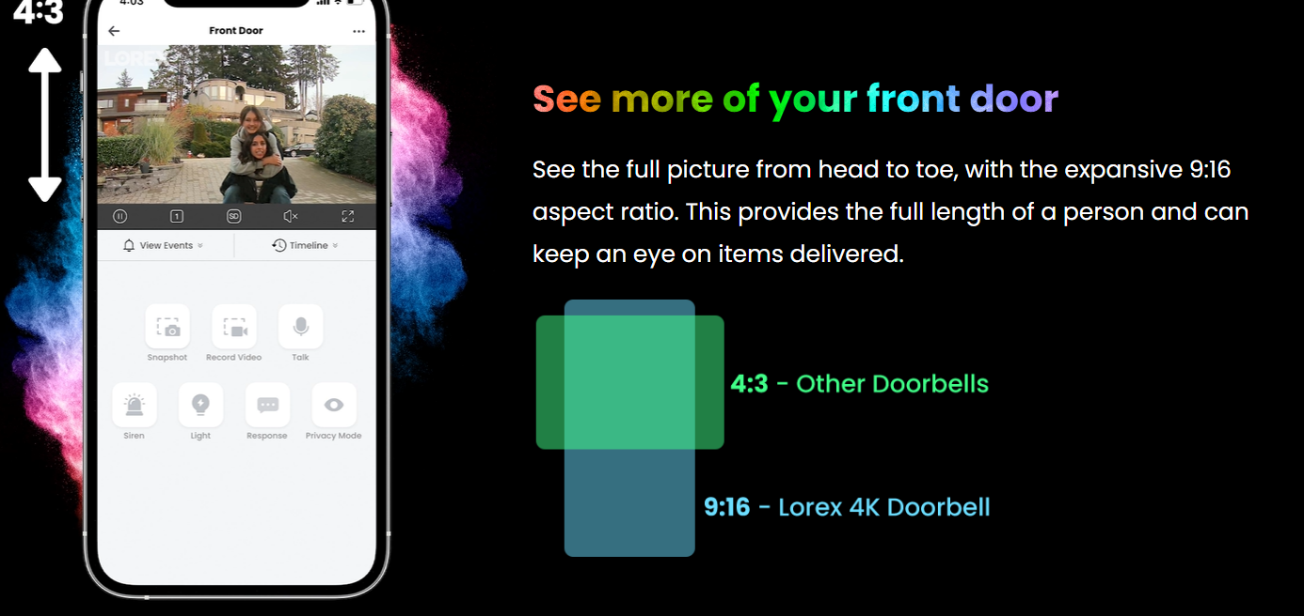

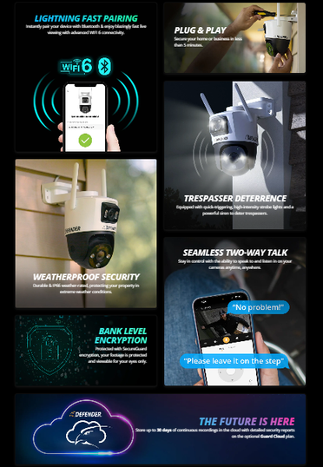

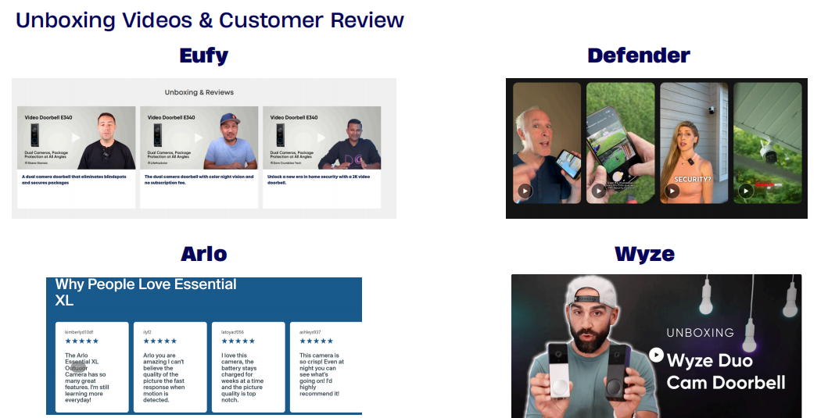

- Add a comparison table that highlights differences between similar products to guide customer decisions.(Maybe Later)

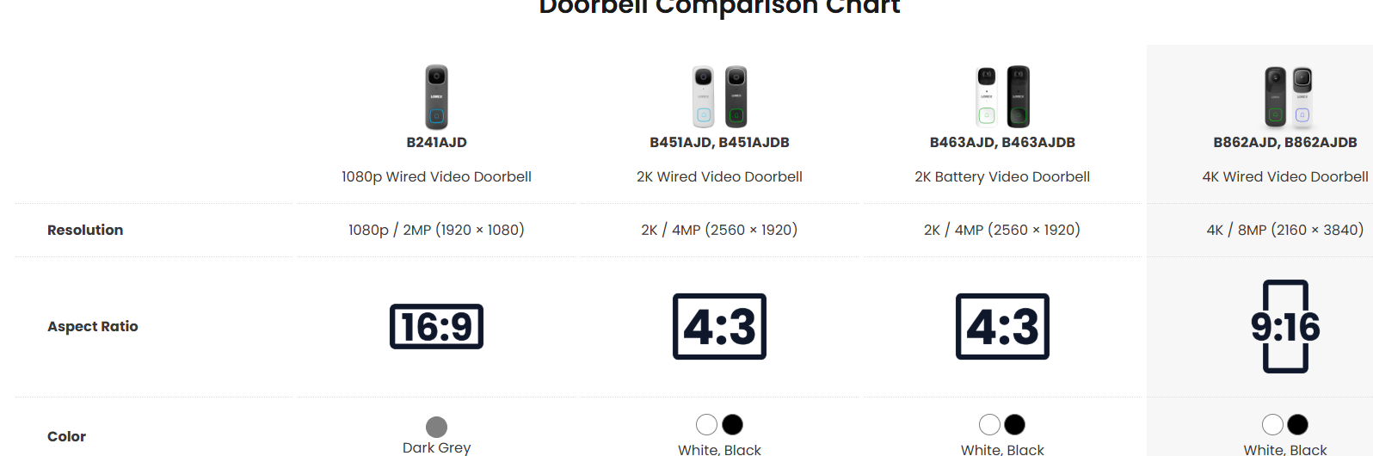

- Include a dedicated FAQ section for each product, addressing common questions about installation, usage, and compatibility.

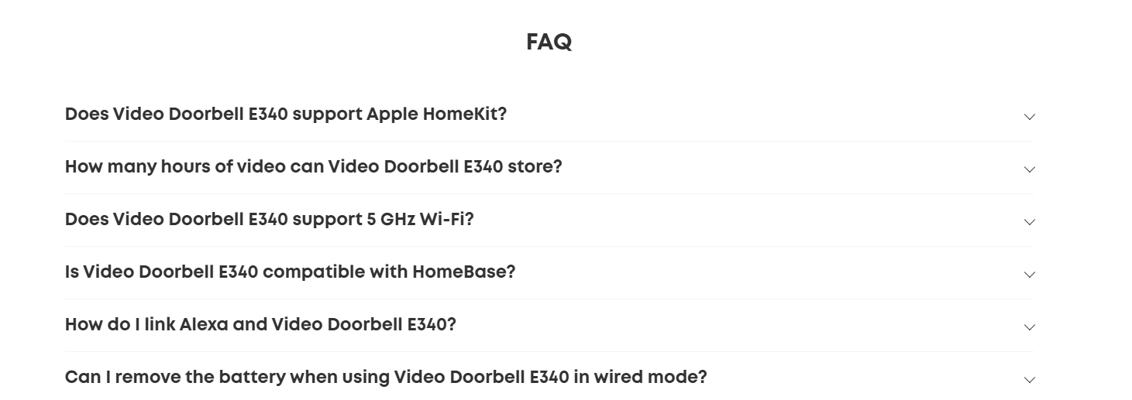

- Add badges or labels like 'Bestseller,' 'New Arrival,' or 'Limited Offer' to products.

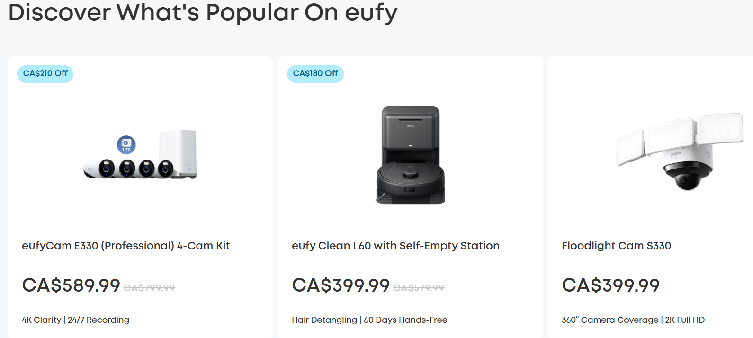

- Display related accessories or complementary items for upselling opportunities.(Maybe Later)

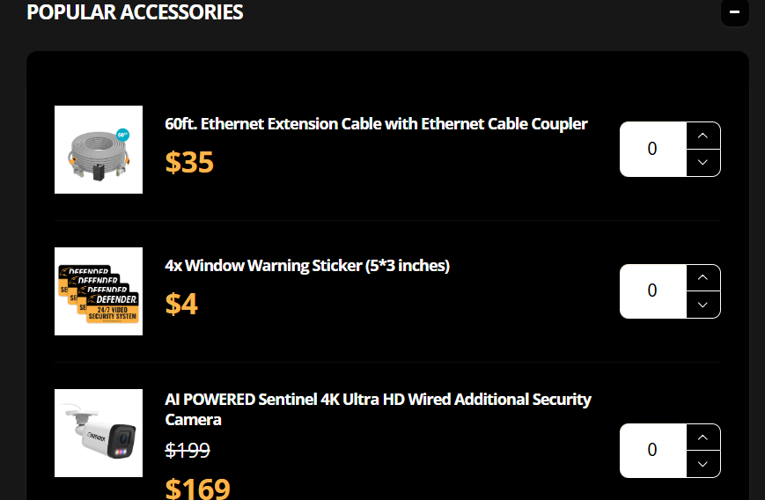

## Online Store Enhancements

- Use hover-based dropdown menus to display subcategories for a smoother shopping experience.

- Allow filtering by price, resolution, features, and intended use (e.g., home, business, outdoor).

- Enable customers to save products for future reference.

- Simplify the process with one-click options and multiple payment methods.

- Clearly communicate shipping options, costs, and return policies on product and checkout pages.

## Visual and Branding Enhancements

- Replace any low-quality images with professionally taken photos and ensure consistency across the site.

- Use a unified design language, including colors, fonts, and icons, to reinforce brand identity.

- Adopt clean and visually balanced layouts inspired by Eufy and Arlo.

## Mobile Optimization

- Ensure the website is fully responsive, with touch-friendly navigation and swipeable galleries.

- Minimize page load times for mobile users.

- Add quick-action buttons like 'Call Support' or 'Buy Now' for mobile visitors.

## Additional Pages

- Expand the 'About Us' page to include the company story, mission, and team introductions.

- Develop a dedicated support center with guides, videos, and downloadable resources.

- Launch a blog with regular updates on security tips, product features, and industry news.

- Create a space for user-generated content, including reviews, forums, and tutorials.

- Include multiple contact options, a contact form, and a map for physical office locations if applicable.

## Others:

